Sophie Donker

Christiaan Kingsale

Sheelah Arends

Natalia Marin

Arduino Sensor – Soil moisture and Conductivity

Values at the University of Aruba

|  |  |
| --- | --- |
| Measurements | Results |
| 1 | sensor = 34 |
| 2 | sensor = 27 |
| 3 | sensor = 8 |
| 4 | sensor = 91 |
| 5 | sensor = 68 |
| 6 | sensor = 12 |
| 7 | sensor = 331 |
| 8 | sensor = 318 |
| 9 | Sensor=856 |
| 10 | Sensor=824 |

Measurements 1 up to measurement 6 were all taken of the soil in garden at the University of Aruba. Some of these measurements vary from each other due to the fact that some of them are exposed to the sun rays for most of the day in comparison to other soil that is party in the sun and party in the shade throughout the day. These are the measurements which we concluded that can be categorized as dry soil.

Measurements 7 and 8 were also taken in the University of Aruba garden however show higher soil moisture that indicates higher and faster conductivity. We concluded that soil measured here coul be categorized as humid soil.

However, measurement 9 was taken in the soil as well but indicated very high soil moisture. We have concluded that this might have to do with the previously mentioned fact that some soil is not exposed to the sun all day long and that measurement could have been taken in an area where there are more nutrients, salts and minerals in the soil which increase the moisture and conductivity. These nutrients, salts or minerals may have ended up in the soil due to run-off or pesticides that may have been used for example.

Measurement 10 was one measurement where we put the sensor in a water bottle. The bottle was tap water.

We calculated the average soil moisture at the University of Aruba as followed:

(34+27+8+91+68+12+331+318+856+824) / 10 = 25.61

With the calculation of the average soil moisture we can conclude that the majority of the soil at the University of Aruba is dry.

Dump:

On October 29, 2017 out class went to Parkietenbos(Dump) to gather some data while we were there. Our group once again had to gather data about the moisture of the soil which indicated the conductivity. It was a cloudy day with little wind. We made our way up to the top of the mountain of waste where all the trucks and other vehicles came to dump their waste. The dump is separated into different areas to throw specific garbage for example for construction waste. As mentioned, we made our way up to the top and started taking some measurements. At first we were fairly close to the construction department. It had rained the day before and the day before that so we kept that in mind when gathering data. There were some mud puddles as well as some areas where it was visible that were moister that others. We decided that since we had set a delay of 20 seconds on our sensor, that we would let the sensor run the data four times after putting the paddle in the soil. It had also rained right before we left; however, we still managed to take measurements at five different locations.

Location #1

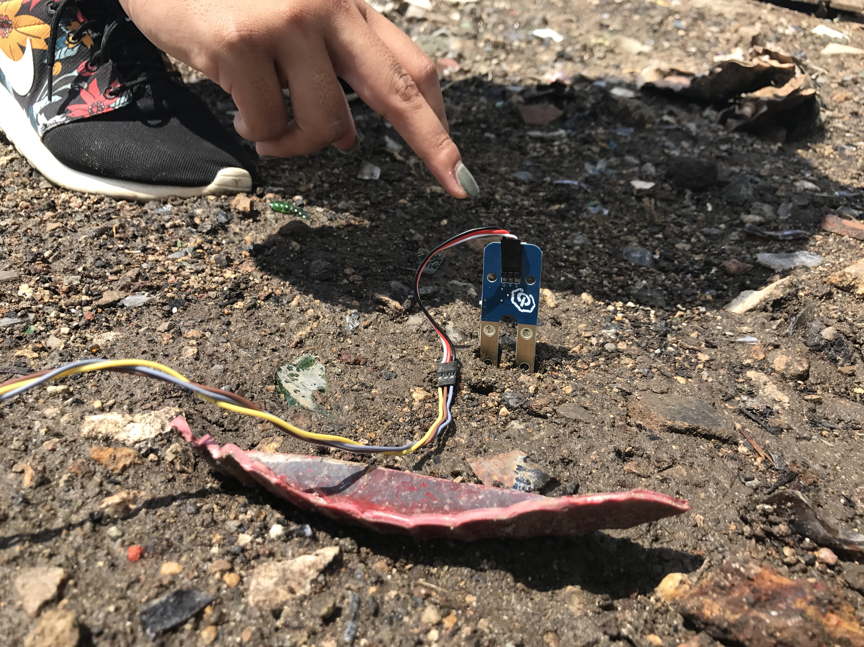

|  |  |
| --- | --- |
| Measurements | Results |
| 1 | Sensor= 1076 |
| 2 | Sensor = 968 |
| 3 | Sensor = 1066 |
| 4 | Sensor = 1076 |

Average at Location #1: (1076+968+1066+1076)/4= 1046.5

Location #2

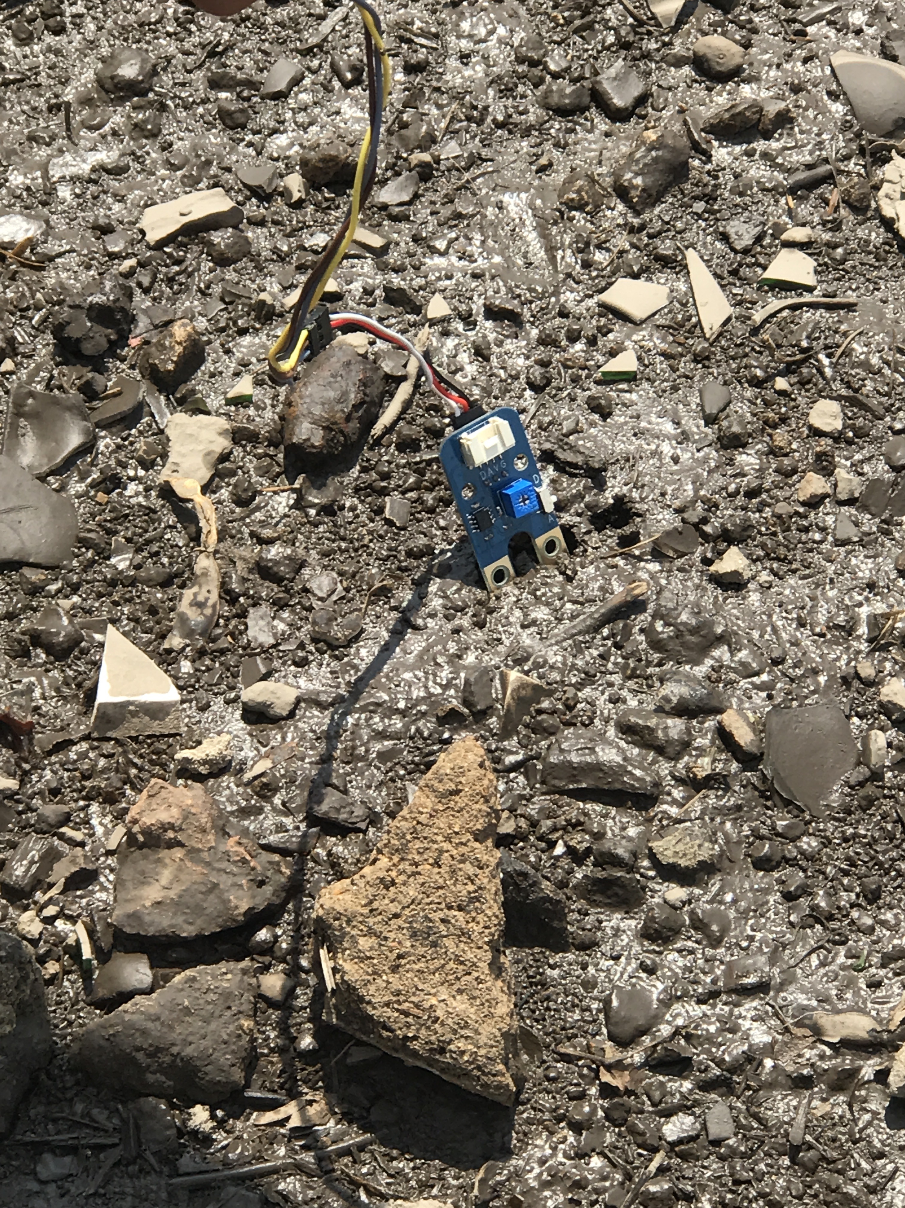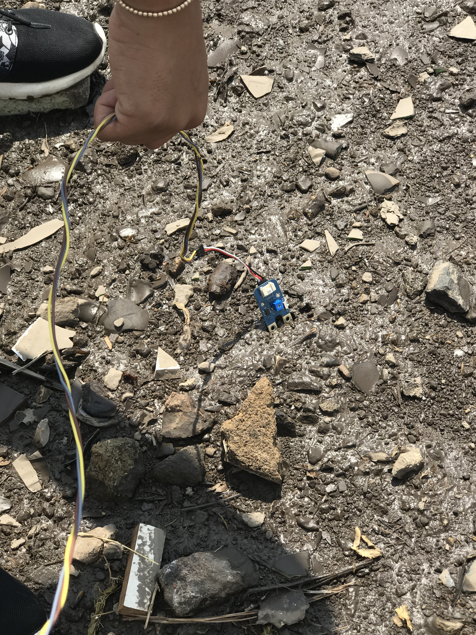

|  |  |
| --- | --- |
| Measurements | Results |
| 1 | Sensor= 1101 |
| 2 | Sensor = 1052 |
| 3 | Sensor = 1033 |
| 4 | Sensor = 985 |

Average at Location #2: (1101+1052+1033+985)/4= 1042.75

Location #3:

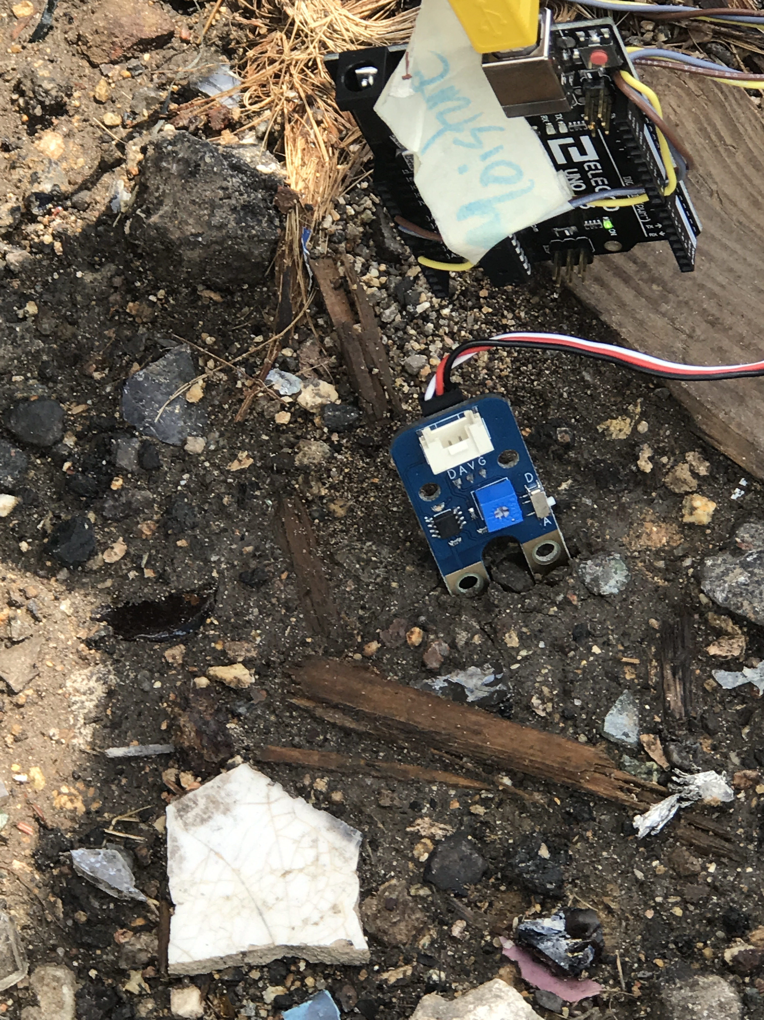

|  |  |
| --- | --- |
| Measurements | Results |
| 1 | Sensor= 1104 |
| 2 | Sensor = 1152 |
| 3 | Sensor = 1114 |
| 4 | Sensor = 1117 |

Average at Location #3: (1104+1152+1114+1117)/4= 1121.75

Location #4

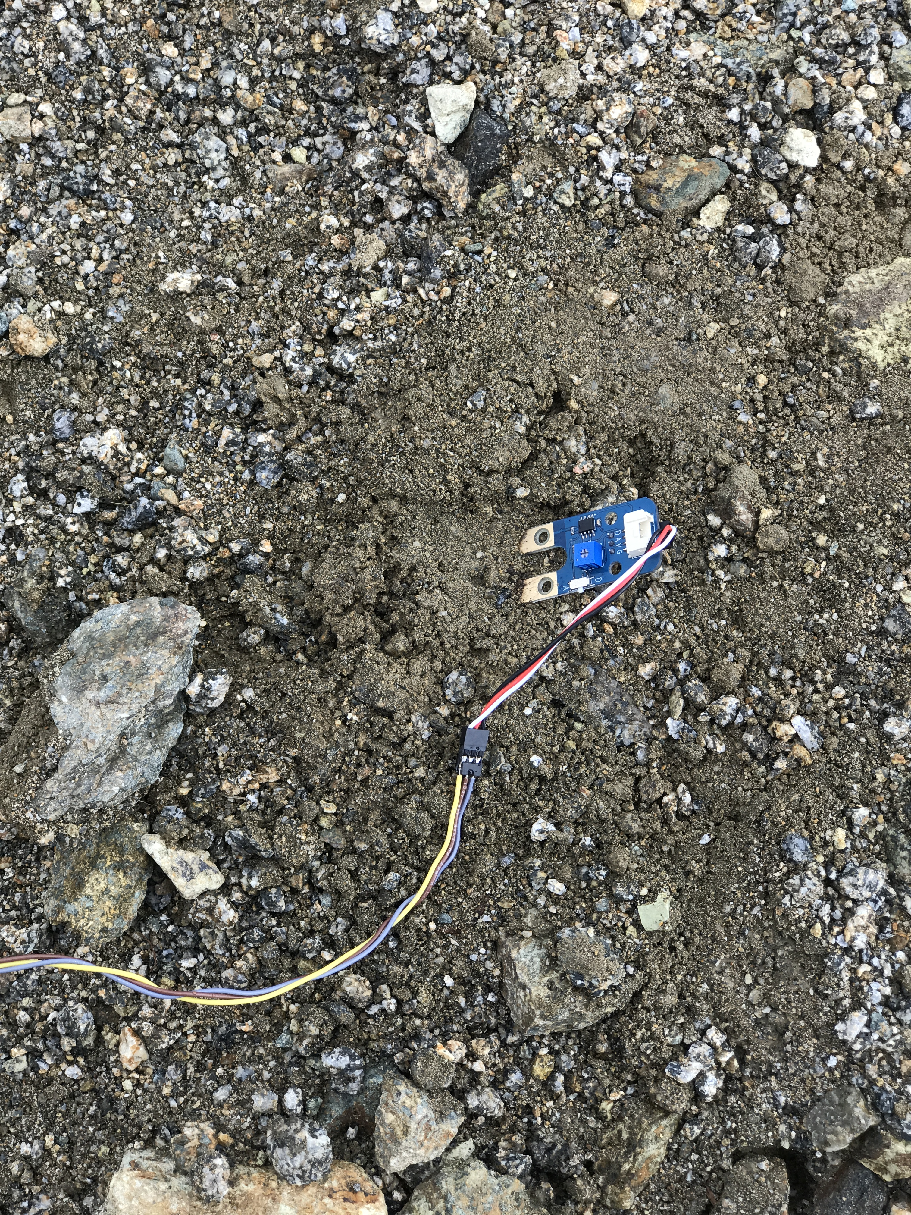

|  |  |
| --- | --- |
| Measurements | Results |
| 1 | Sensor= 188 |
| 2 | Sensor = 467 |
| 3 | Sensor = 429 |
| 4 | Sensor = 453 |

Average at Location #4: (188+467+429+453)/4= 384.25

Location #5

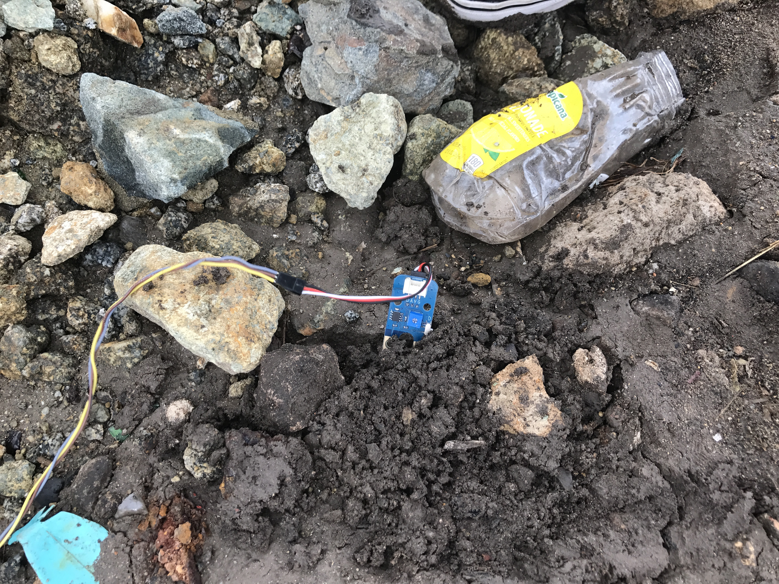

|  |  |
| --- | --- |
| Measurements | Results |
| 1 | Sensor= 142 |
| 2 | Sensor = 148 |
| 3 | Sensor = 154 |
| 4 | Sensor = 166 |

Average at Location #5: (142+148+154+166)/4= 152.5

Average of all measurements at Parkietenbos: (1046.5 +1042.75 +1121.75 +384.25 + 152.5)/4= 936.9375

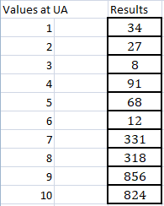 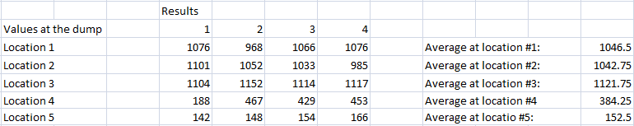

**Compare measurements of UA with Dump**: After calculating the average measurements of the University as well as the Dump it is obvious that all the results from the dump are higher than those at the university. The university showed an average of 25.61 and the dump showed an average of 936.9375. Thus, the university soil can be characterized as dry soil and the dump is more humid. The humidity of the soil at the dump has to do with the rainfall from the days before; however, the higher results are not only caused by the moisture of the soil. The results shown indicate the (electrical) conductivity of the soil. The conductivity is high when the soil is moist but even higher if the soil contains lots of salts, nutrients and minerals. It is believed that at dump sites the pH levels and the amount of ions in the ground are higher, leading to higher electrical conductivity. This means that the ground does not necessarily have to be moist for the conductivity to be high. Another factor that determines the conductivity is the salinity of the soil. The materials that are disposed of at the dump contribute to the salinity of the soil there.

Observations made while taking measurements:

When we got to the dump it was very hot and there was little wind; however, there were some big gray clouds, which is why we anticipated that it was going to rain. We made our way up the hill and realized that it was pretty muddy and the soil was still looking ‘wet’. We tried finding different areas that were maybe different from each other to see if we would get different values. Some parts looked dryer than others but not as dry as the soil at the University. We gathered some measurements for tree different spots in a part of the “dump” where we expected it to be humid, next to that there was allot of construction waste. We started in a part where we were expecting it to be humid, next to that is where there is a lot of construction waste. Later on we crossed the ‘street’ where the trucks pass and measured there. After the second measurement it had started raining so we went to hide in the car and got out when the rain had partially stopped. We measured in an area where there was a pile of sand that seemed dry in comparison to the soil surrounding it. We tried measuring the sand of the road where the trucks pass, but the soil was to hard/dry for us to put the sensor in the ground.

Dump values compared to international standards

Aruba lies in a dry climate zone, it's subclimate is semiarid. This means that it rains a bit more than 10 inches per year, but in general it's still dry. This also means that most of Aruba is dry soil. According to the table of our sensor's output values this means that most of our measurements should have a value of between 0 and 300. At the dump we measured some values that seemed way to high compared to the standard values we should be getting for dry or a slightly humid soil. This doesn't necessarily mean that it is extremely humid soil or water. A lot of burning of materials takes place at the dump, this also means that the soil gathers more and more salts and nutrients. This makes the soil more fertile,but this also means that the conductivity of the soil becomes higher, because of all the salts in the ground, the transportation of electron becomes easier than normal. So because of a high concentration of salts in the soil, the value of conductivity is higher than usual, regardless if the soil doesn't seem that humid.

